Updated June 24, 2013
 | Duration | Drought Tolerant | Growth Habit | Reported Hardiness
Apache Plume  Fallugia paradoxa | Perennial  Deciduous | Yes. But does like a little indirect water on an irregular basis, especially in warmer areas. | Shrub. Plumes appear in late summer.  May not bloom fully for the first year until established root system.  Moderate to fast growth. | To 0° | 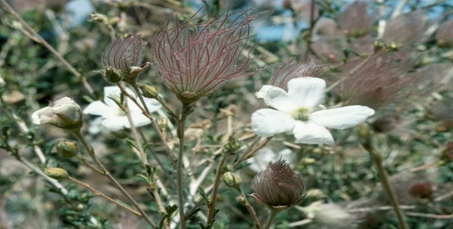
Bird of Paradise  Shrub  Caesalpinia gilliesii | Perennial  Deciduous | Low water | Loosely branched, multi-trunked shrub. Unique red and yellow colors. Produces pods. | To 20° | 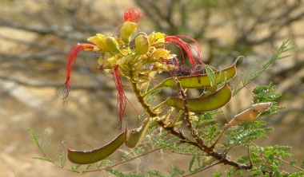
Catmint  Nepeta cataria | Perennial.  Long lived reported 8 yrs and growing.  Divide to replant. | Needs little water. | Mounding clump18-30" tall, 3 - 4' wide. Blooms all summer, better in full sun, but can take some shade. Cut back in winter.  Attracts pollinators. |  | 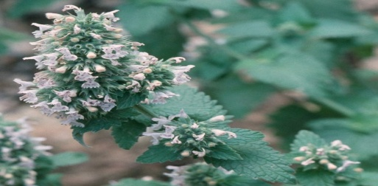
Gaillardia  Gaillardia pulchella | Perennial | Requires little to moderate water.  Not fussy about soil type. | Beautiful blooms from late spring to frost. Reseeds. |  | 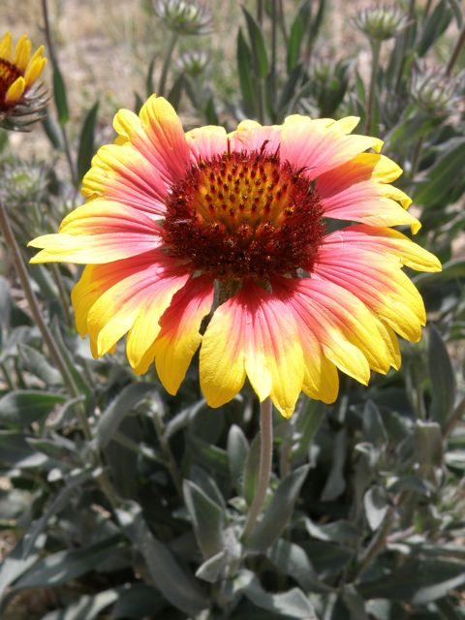
Penstemon  Penstemon barbatus | Perennial  Original lasts only 3-4 years | Requires little to moderate water. Requires no fertilizer.  Not fussy about soil type. | Beautiful, blooms in summer in variety of colors, sizes, shapes. Reseeds readily. |  | 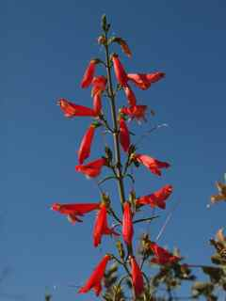
Jupiter's Beard  Centranthus ruber | Perennial; dies back in winter. | Moderate water | Small dark-pink or white flowers atop 2- to 3-foot stems. It grows equally well in bright shade to full sun and blooms from late spring to mid-summer. Propagate by division oar seed. | To -30° | 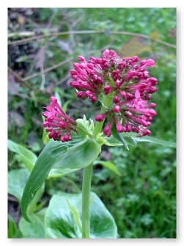
Russian Sage | Non-native |  | Almost considered invasive.
Larkspur  Delphinium scaposum | Perennial; dies back. | Water: dry to normal. | Beautiful blooms from spring to frost.  Comes in blue, a flower color that is hard to find. |  | 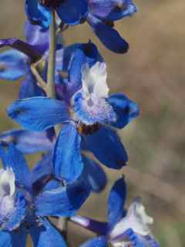
Gaura -  Whirling Butterflies  Gaura lindheimeri | Perennial  Native | Occasional water after established | Grows commonly in our area.  Pink to Red flowers; low ground with protruding arches of flowers; attracts pollinators..  Watch out you might mistake as an unwanted weed! |  | 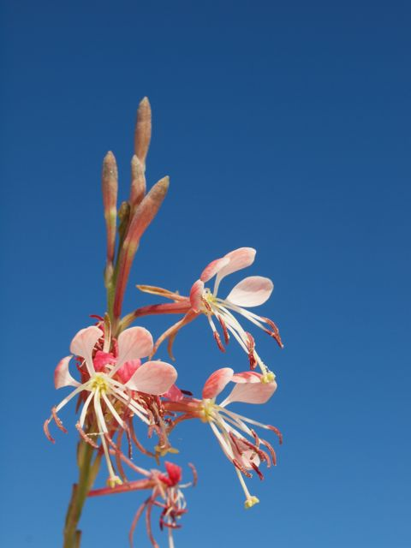
Silver Lace Vine  Polygonum aubertii | Deciduous, non-native | Drought tolerant | Deciduous twining vine; greenish white flowers; reddish new growth; 10 to 15 feet |  | 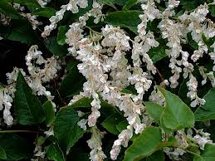
Canyon Grape  Vitis Arizonica | Deciduous | More water the more grapes.  Local grape experts state ~40 gallon weekly or 8 gallon every other day to produce grapes. | A sprawling, scrambling, branched and woody vine.  Take three seasons to produce blow or bloom then grapes.  Grapes are said to be good jelly or wine producers. |  | 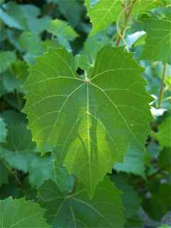
Whole-leaf Indian Paintbrush  Castilleja Integra | Deciduous, perennial, native | Rainfall only | Reseeds into beautiful color across natural land spaces.  Needs host plant of native grass or Fringed sage (Artemisia frigida). |  | 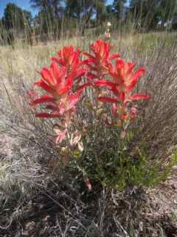
Fine Leaf Yucca  Yucca Augustissima | Evergreen,  native | Drought tolerant once established  Pretty much any yucca is a tough plant. | Long lasting pale pinkish to yellow flowers attracts hummingbirds and butterflies; great desert landscape plant.  Good for rock gardens and western type gardens; has interesting form. 3 to 6 foot tall stalk (racemose) |  | 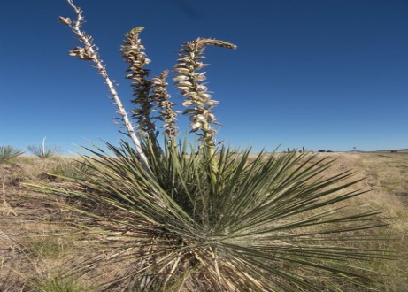

Cited Sources:
a) By conversation with garden club members named following common and scientific plant name.
b) Northern Arizona Flora Database (http://www.nazflora.org), 3 June 2013. The website development sponsored by The Arizona Native Plant Society (http://www.aznps.com)
c) USDA, NRCS. 2013. The PLANTS Database (http://plants.usda.gov, 5 March 2013). National Plant Data Team, Greensboro, NC 27401-4901 USA. Photos by Gary A. Monroe @ USDA-NRCS PLANTS Database

d) Yavapai County Native and Naturalized Plant Database (http://cals.arizona.edu/yavapaiplants)

